Grade Journey for eLearn Ultra (Gradebook)
- For the teaching course site
Step 1: Post Grades


This guide explores on how to post the grades before the grade transfer in eLearn Ultra Gradebook.
To view the gradebook in grid format, navigate to the Gradebook on top panel and click on Grades.
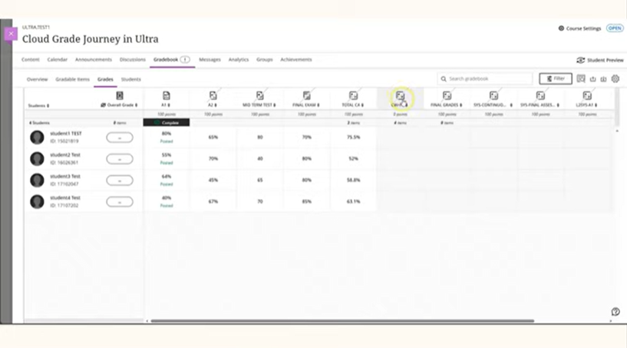

In eLearn Ultra course, kindly ensure all assessment grades are posted before initiating the grade transfer. To post grades, click on the Grade column header and click Post.
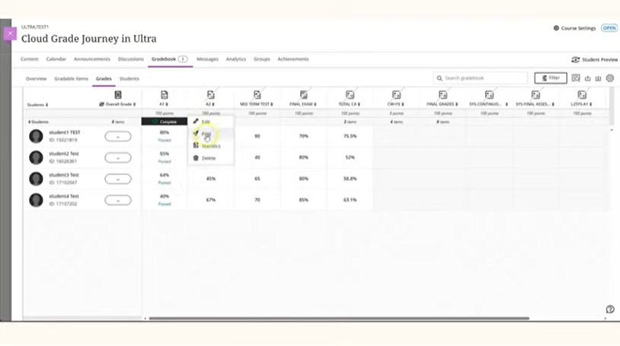
Confirm the post by clicking the Post All Grades button on the pop-up screen.
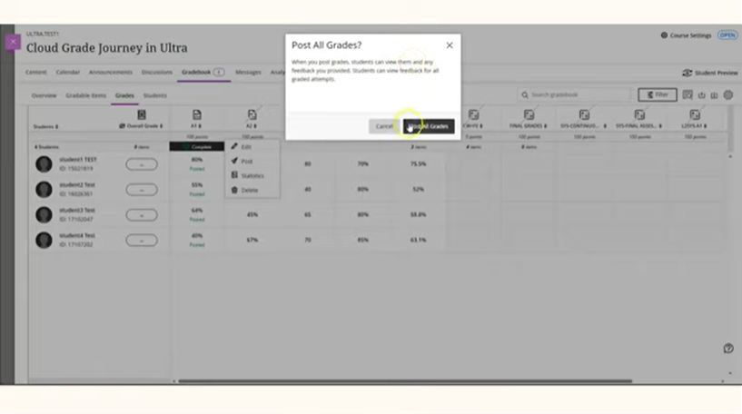

Repeat these steps for each individual assessment column to post all grades for all students.

End of Guide

